CHAPTER 1
INTRODUCTION

MEAN Stack

MEAN Stack is a popular full-stack JavaScript technology stack used for developing modern web applications. MEAN stands for MongoDB, Express.js, Angular, and Node.js. It provides technologies for developing the frontend, backend, and database of a web application.

Importance of MEAN Stack
MEAN Stack simplifies web application development by using JavaScript across different layers of the application. It helps developers build applications faster, reduce development complexity, and maintain a consistent programming language throughout the project. It is suitable for developing dynamic, scalable, and interactive web applications.

Basic Terminologies
- MongoDB: A NoSQL database used to store and manage application data in document format.
- Express.js: A lightweight web framework for Node.js used to develop backend applications and APIs.
- Angular: A frontend framework used to create dynamic and interactive user interfaces.
- Node.js: A JavaScript runtime environment used to execute JavaScript on the server side.
1.4 Components of MEAN Stack

1.4.1 MongoDB
MongoDB is a NoSQL database that stores data in flexible document-based formats. It is used to store and retrieve application data efficiently.
1.4.2 Express.js
Express.js is a backend framework built on Node.js. It is used to create server-side applications, handle HTTP requests, and develop REST APIs.
1.4.3 Angular
Angular is a frontend framework used to develop dynamic web pages and interactive user interfaces. It supports components, routing, forms, and data binding.
1.4.4 Node.js
Node.js is a JavaScript runtime environment that allows JavaScript code to run on the server. It is commonly used with Express.js to build backend services.

1.5 Operations in MEAN Stack
Common operations include:
- Create: Adding new data to the application.
- Read: Retrieving stored data.
- Update: Modifying existing data.
- Delete: Removing data from the database.
- API Communication: Transferring data between frontend and backend.
1.6 Need for MEAN Stack
MEAN Stack provides:
- Full-stack development using JavaScript
- Faster and easier development
- Efficient database management
- Dynamic and interactive user interfaces
- Scalable backend applications
- Easy communication between frontend and backend
1.7 Applications of MEAN Stack
MEAN Stack is used in:
- E-commerce applications
- Online food ordering systems
- Social media applications
- Content management systems
- Booking and reservation systems
- Real-time web applications
- Business and management applications

CHAPTER 2

METHODOLOGY

2.1 Objective
The main objective of the Smart Canteen Pre-Order and Queue Management System is to reduce waiting time and overcrowding in college canteens by providing an online platform where students can browse food items, pre-order meals, select capacity-controlled pickup slots, make payments, and track their order status. The system also helps administrators efficiently manage food items, categories, pickup slots, orders, users, feedback, and sales. By automating the ordering and queue management process, the system aims to improve canteen efficiency, minimize manual work, prevent overbooking, and provide a convenient and organized experience for both students and canteen administrators.

2.2 Problem Statement
College canteens often face problems such as long queues, overcrowding during peak hours, delayed food service, and difficulty in managing orders manually. Students have to wait in queues to place orders and collect their food, while canteen administrators may find it difficult to manage orders, food availability, pickup times, and customer information efficiently. There is also a risk of overbooking during busy periods. The Smart Canteen Pre-Order and Queue Management System is proposed to address these problems by providing an online platform for pre-ordering food, selecting capacity-controlled pickup slots, tracking orders, and efficiently managing canteen operations.

2.3 Project Description
The Smart Canteen Pre-Order and Queue Management System provides separate functionalities for Students and Administrators to make food ordering and canteen management simple and efficient.
Student / Customer Functionalities
- User Registration and Login: Students can create an account using their name, email, phone number, and password and log in to the system.
- Menu Browsing: Students can view food items by category, search for items, and check their availability.
- Food Details: Students can view food images, descriptions, prices, and select the required quantity.
- Shopping Cart: Students can add, remove, and update food items and view the total order amount.
- Pickup Slot Reservation: Students can select an available pickup time slot based on its capacity.
- Pre-Order: Students can place food orders and select a payment method such as Counter Cash or UPI.
- Order Tracking: Students can track their orders through Placed, Accepted, Preparing, Ready for Pickup, and Completed stages.
- Order History: Students can view previous and current orders with order details and order IDs.
- Feedback and Ratings: Students can provide 1–5 star ratings and comments about the food and service.
Admin Functionalities
- Admin Dashboard: Displays important information such as registered users, menu items, orders, pending orders, completed orders, and sales.
- Food Menu Management: Admin can add, edit, delete, and update the availability of food items.
- Category Management: Admin can add or delete food categories.
- Pickup Slot Management: Admin can create pickup slots, set their maximum capacity, and manage their availability.
- Order Management: Admin can view orders, filter them by status, and update their progress.
- User Management: Admin can view registered users and activate or deactivate their accounts.
- Feedback Management: Admin can review student ratings and feedback.
- Reports and Analytics: Admin can view order statistics, revenue information, and popular food items.
CHAPTER 3

RESULTS AND DISCUSSION

Screenshots:

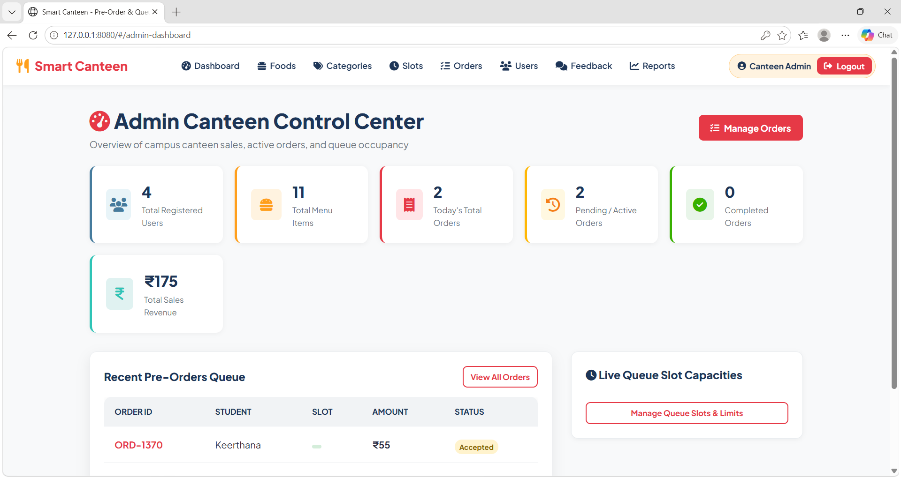

Fig 3.1 : Admin dashboard

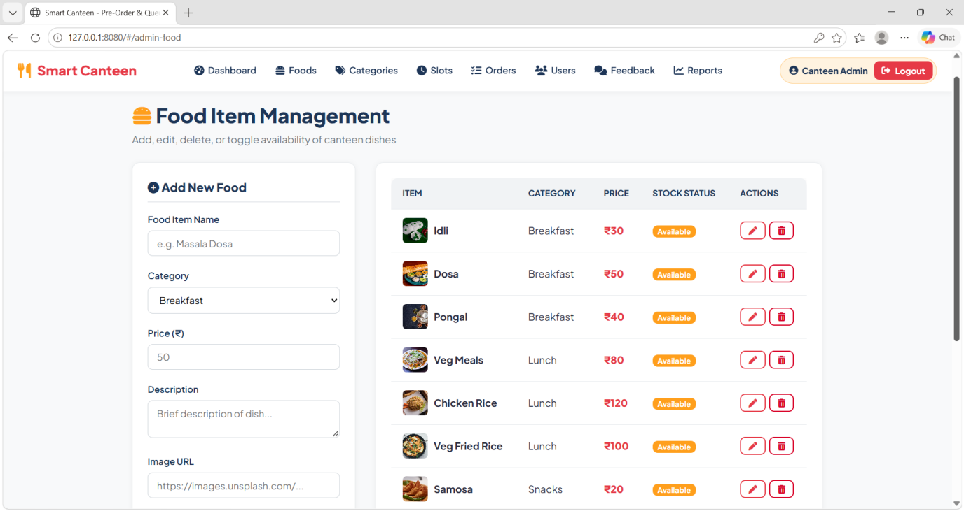

Fig 3.2 : Food Item Management

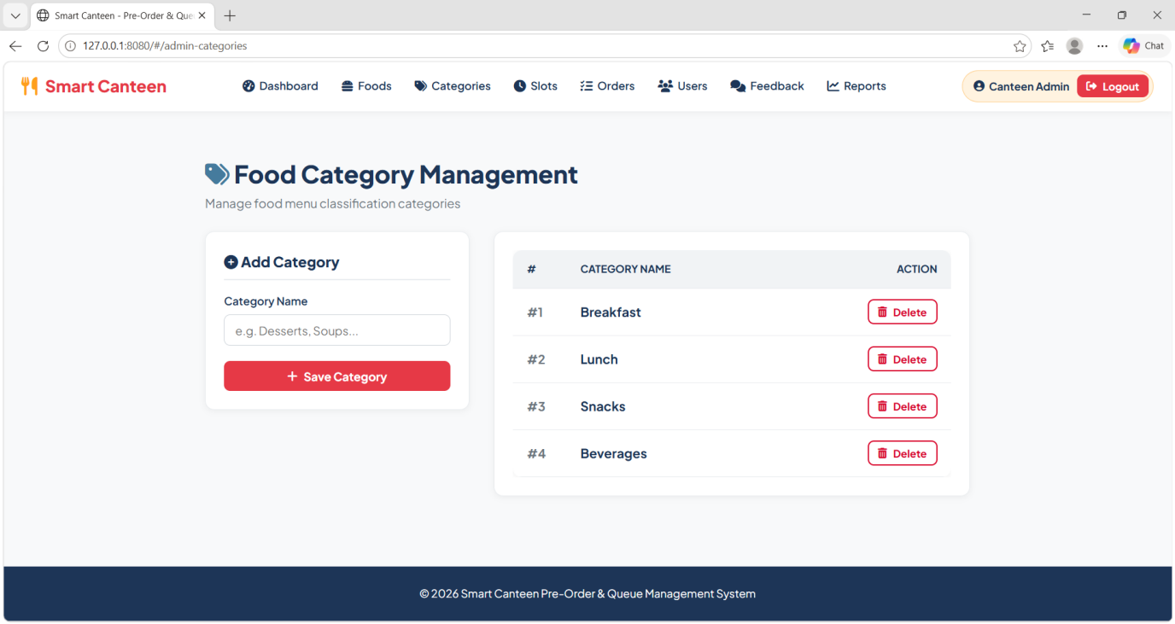

Fig 3.3 : Category Management

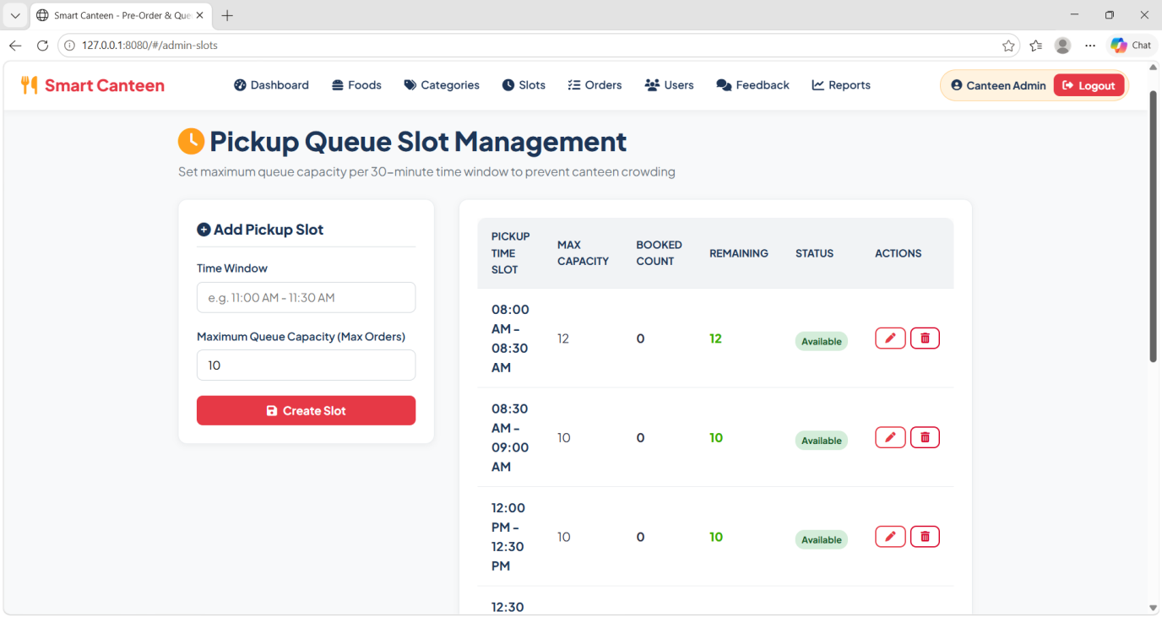

Fig 3.4 : Slot Management

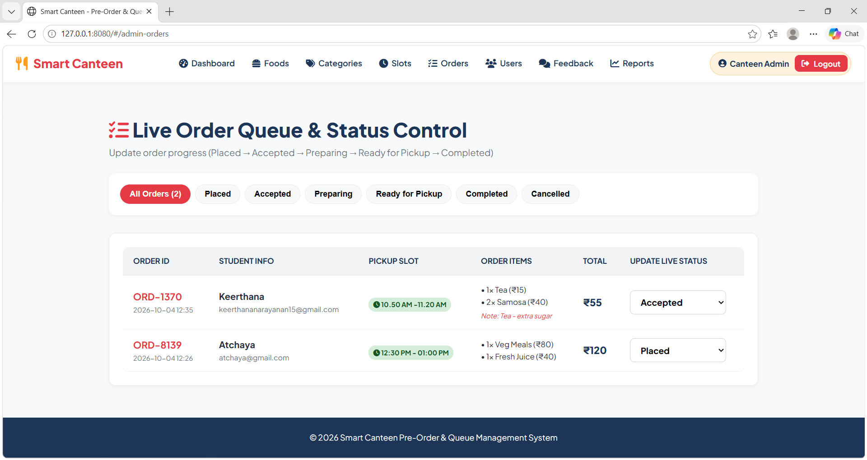

Fig 3.5 : Orders Management

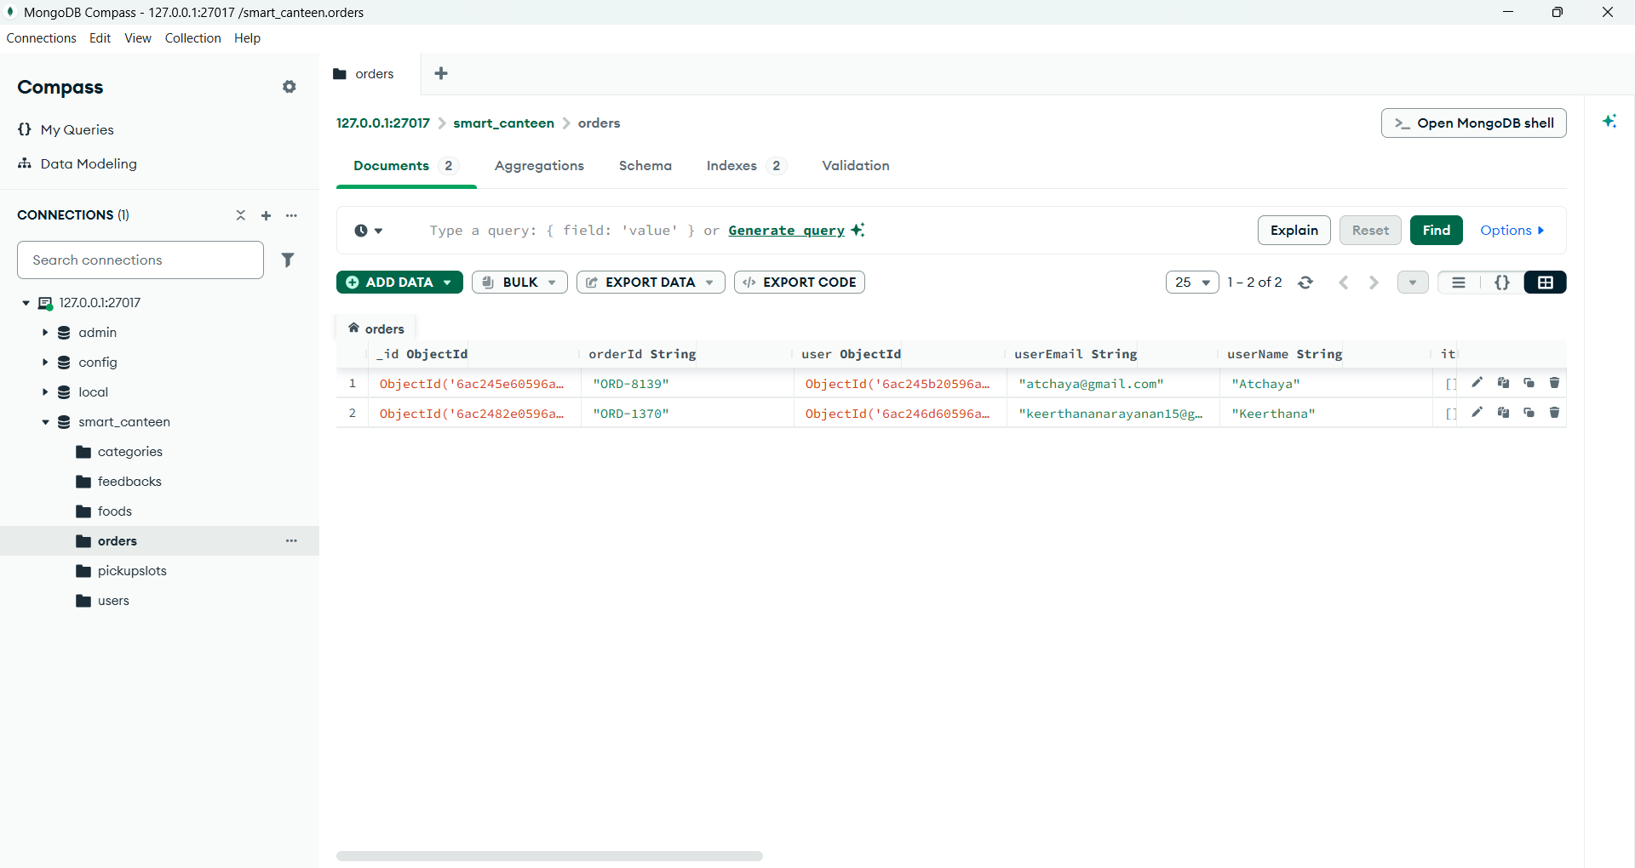

Fig 3.6 : Orders in DB

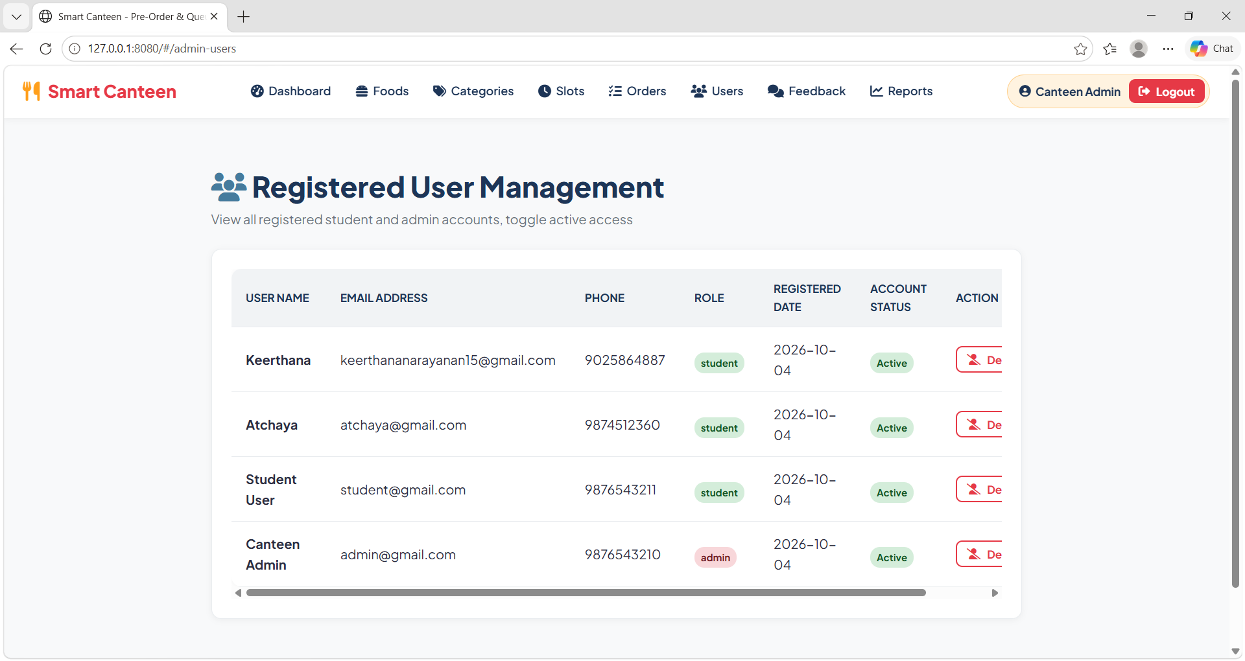

Fig 3.7 : User Management

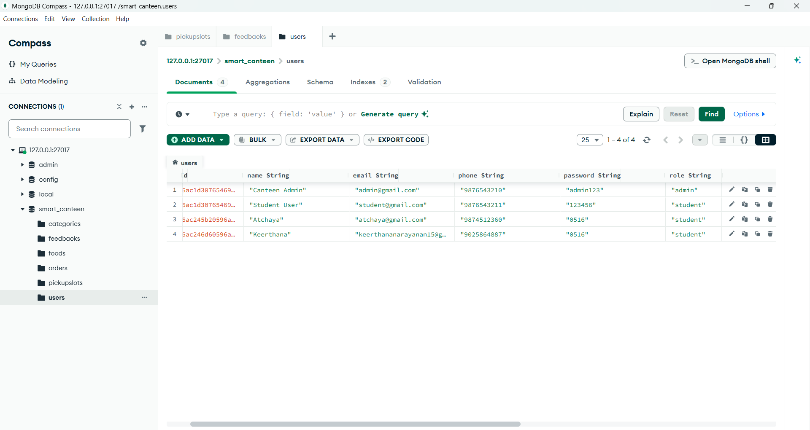

Fig 3.8 : User in DB

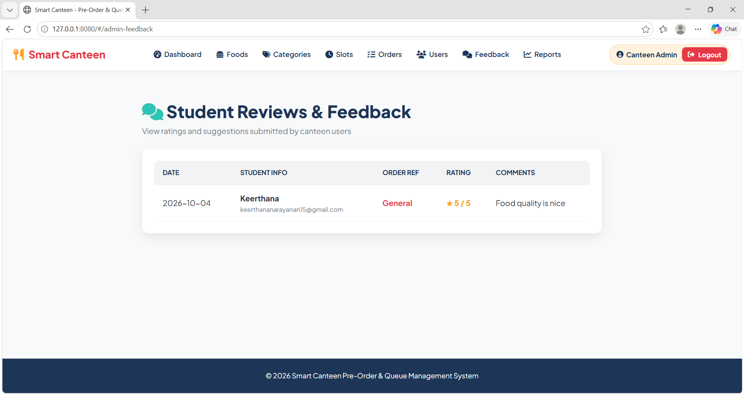

Fig 3.9 : Feedback

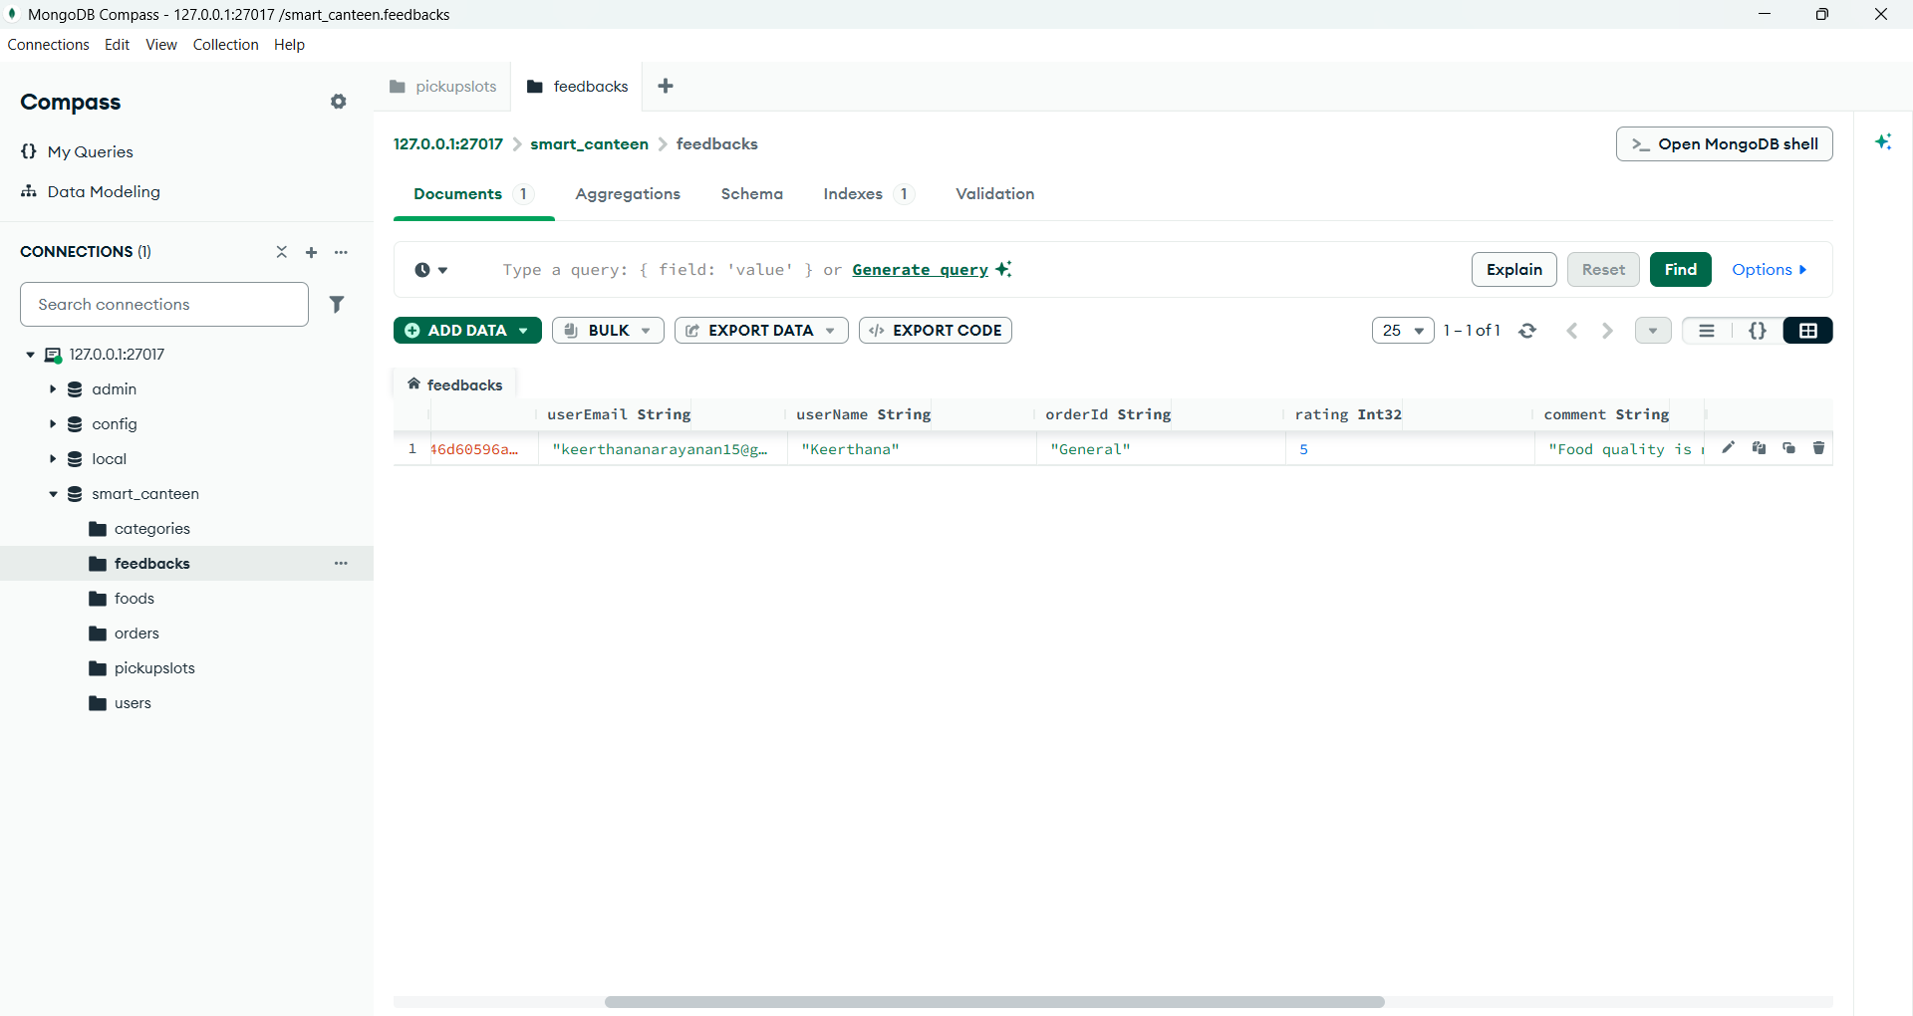

Fig 3.10 : Feedback in DB

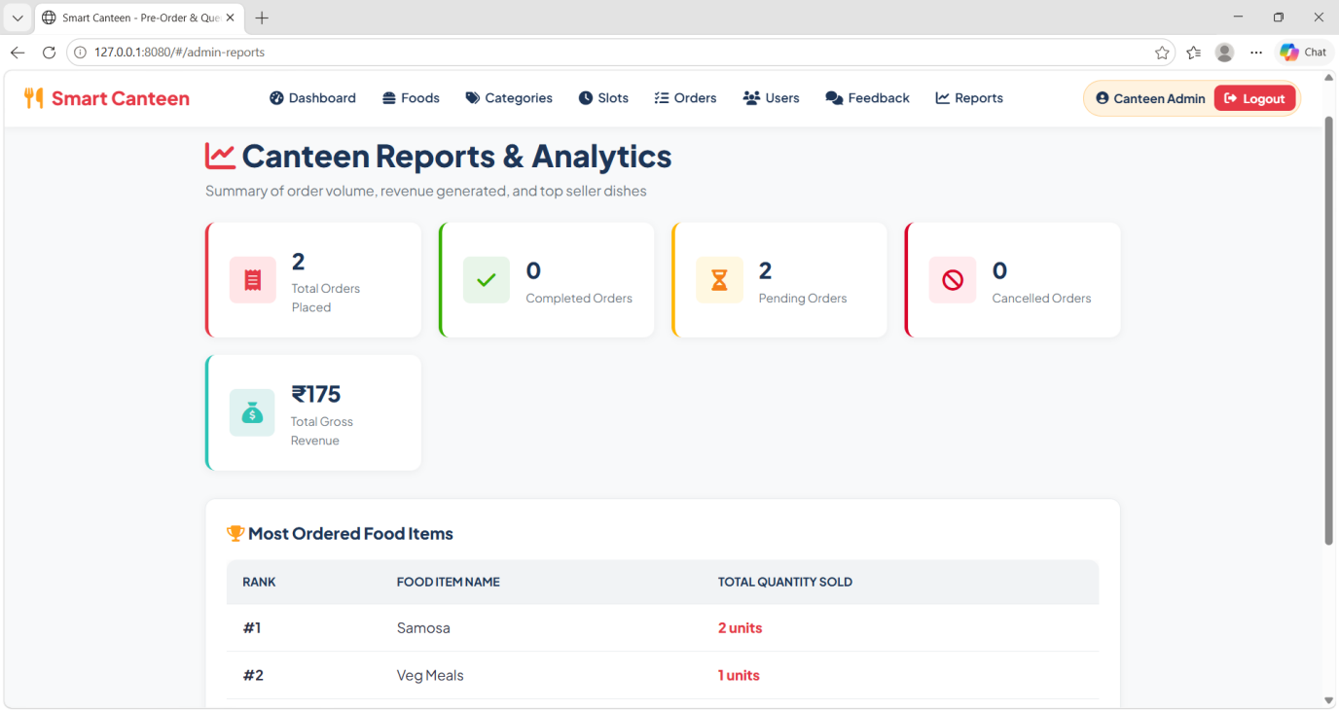

Fig 3.11 : Report

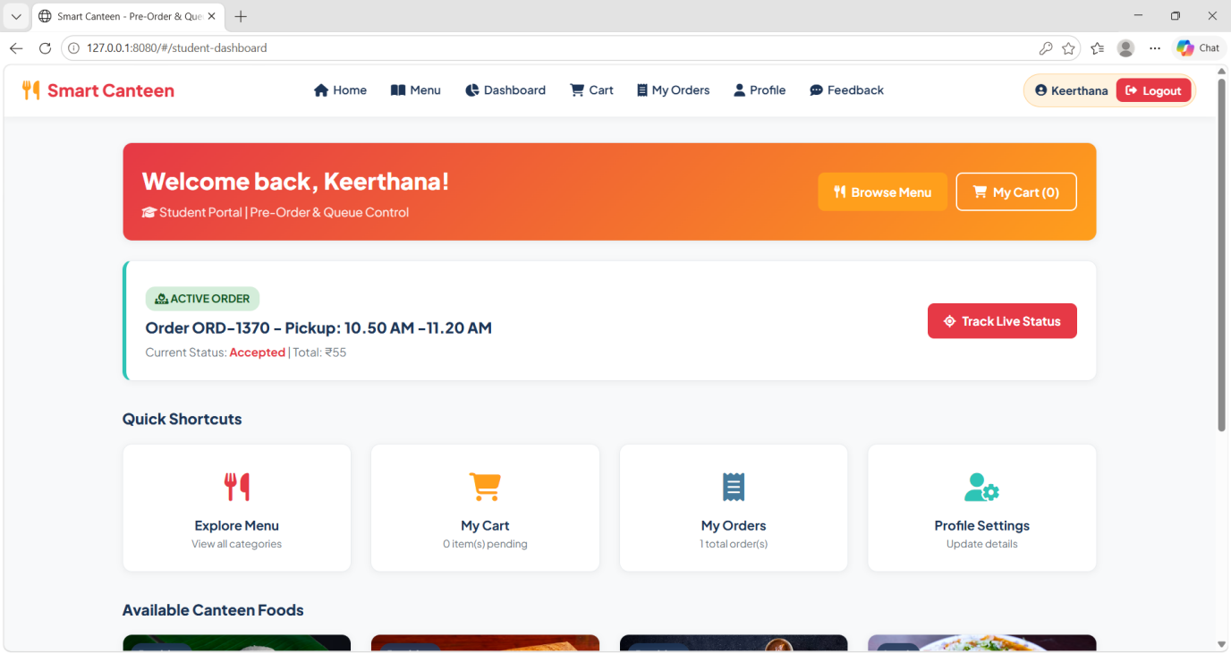

Fig 3.12 : Student Dashboard

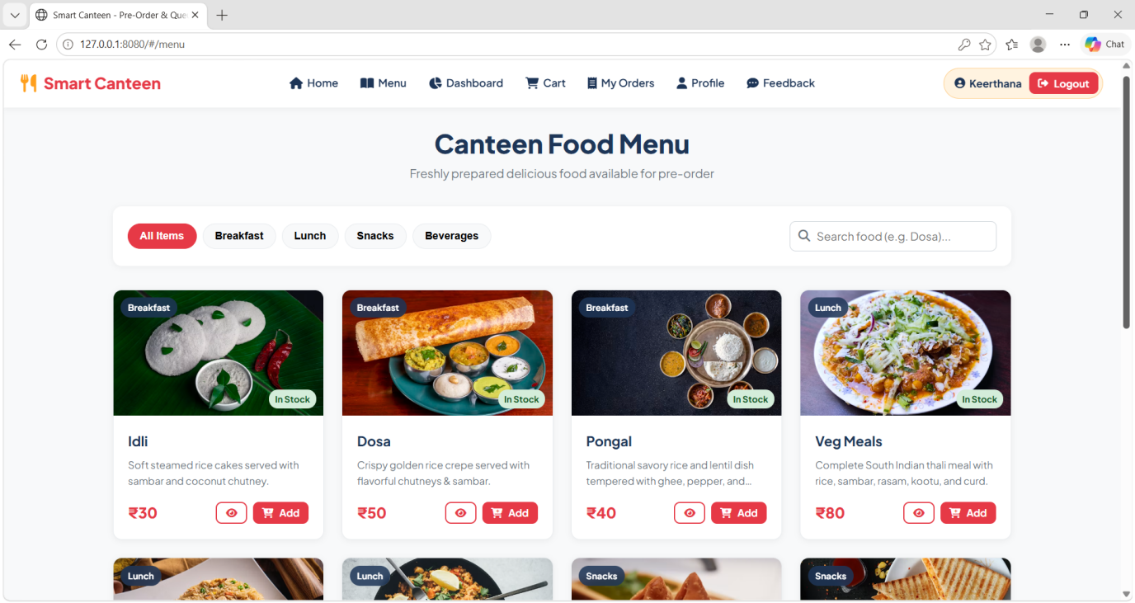

Fig 3.13 : Menu

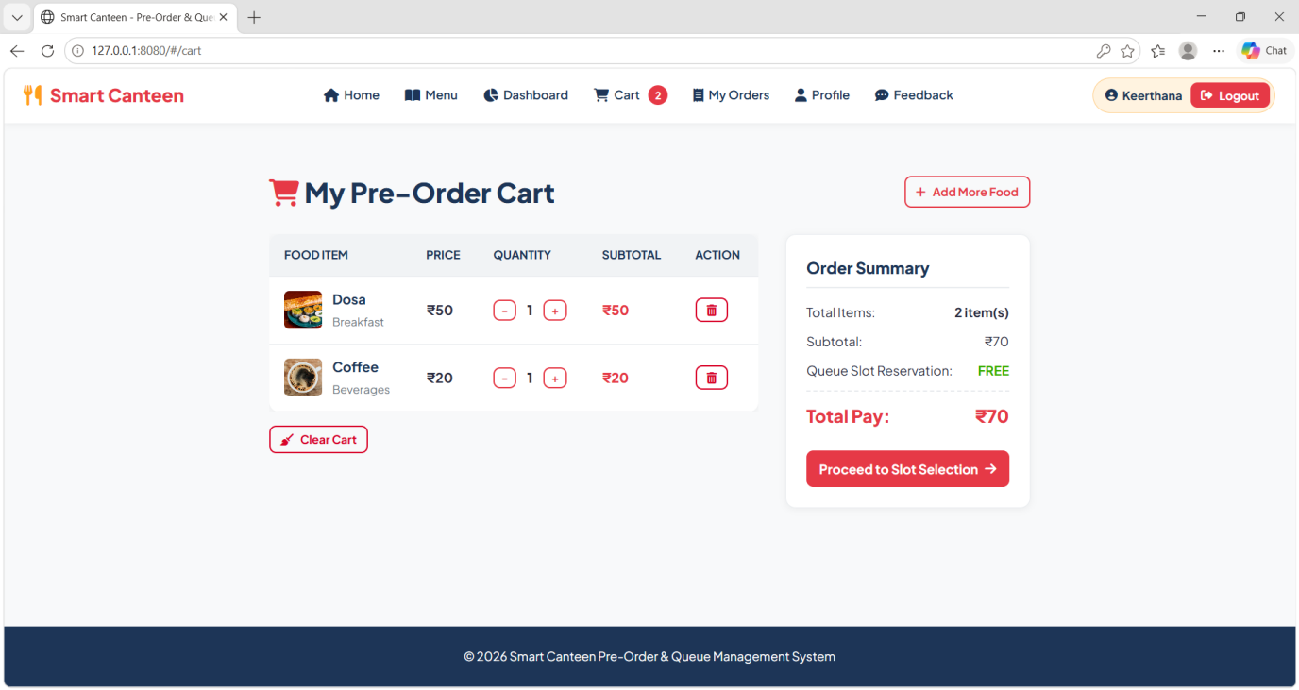

Fig 3.14 : Cart

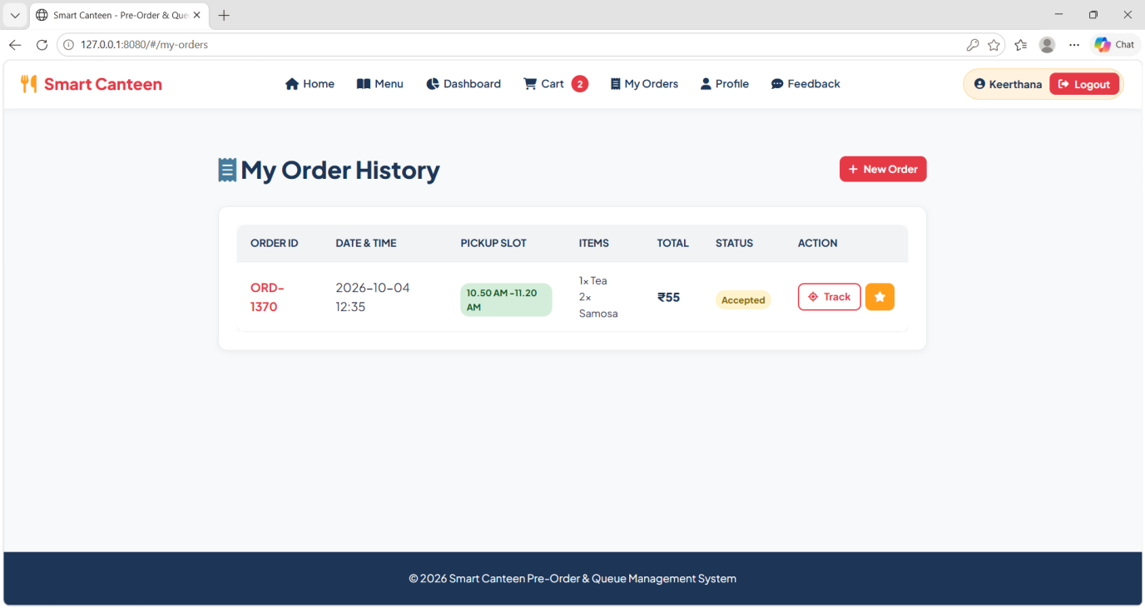

Fig 3.15 : Orders

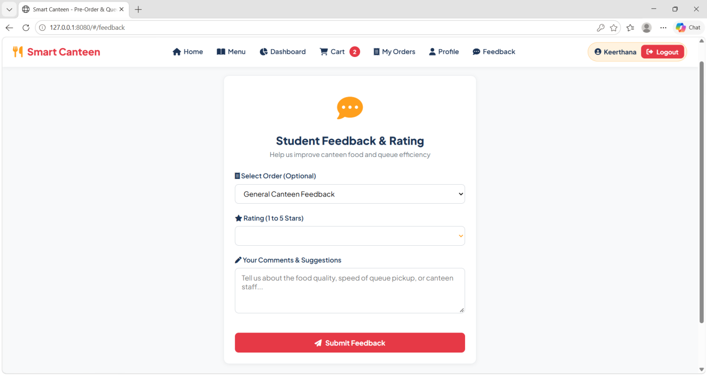

Fig 3.16 : Feedback

Github Link: https://github.com/NKeerthana16/Smart-Canteen

CHAPTER 4

CONCLUSION
The Smart Canteen Pre-Order and Queue Management System provides an efficient and user-friendly solution for managing food ordering and queues in college canteens. The system allows students to browse food items, add them to the cart, select available pickup slots, place pre-orders, track their orders, and provide feedback. The admin module helps manage food items, categories, pickup slots, orders, users, feedback, and sales information. By reducing long queues, waiting time, overcrowding, and manual work, the system improves the overall efficiency of canteen operations. The project also demonstrates the practical application of AngularJS, HTML5, CSS3, JavaScript, Node.js, Express.js, and MongoDB in developing a real-world full-stack web application. Overall, the system provides a convenient and organized platform that benefits both students and canteen administrators.

REFERENCES
- Elmasri, R., & Navathe, S. B. Fundamentals of Database Systems (7th ed.). Pearson.
(Referenced for database design, data management, and database concepts.)
- Freeman, E., & Robson, E. Head First JavaScript Programming. O'Reilly Media.
(Referenced for JavaScript programming, event handling, and web application concepts.)
- Tilkov, S., & Vinoski, S. (2010). Node.js: Using JavaScript to Build High-Performance Network Applications. IEEE Internet Computing, 14(6), 80–83.
(Referenced for Node.js, asynchronous programming, and server-side application development.)
- Gross, D., Shortle, J. F., Thompson, J. M., & Harris, C. M. Fundamentals of Queueing Theory (4th ed.). Wiley.
(Referenced for queue management, waiting-time reduction, and capacity-based scheduling.)
- Silberschatz, A., Korth, H. F., & Sudarshan, S. Database System Concepts (7th ed.). McGraw-Hill.
(Referenced for database management, data organization, and transaction concepts.)

